Class Exercise 2 – Modern Gas Station

In this exercise, you will create User Requirements for a state of the art gas station. Pretend your group is in charge of coming up with the next generation of gas stations, and the only constraint you have is that the updates must be available with current or emerging technologies.

Come up with at least 10 Functional Requirements, and 5 non-Functional (performance) requirements. Each requirement statement **shall** contain a shall.

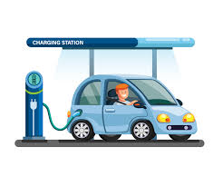These are User Requirements. This means that they are basically a wish list of things that you (the User) would like to see as part of this new generation of “gas” stations.

+ ?? = ??

+